VPython Modeling Lab
Objectives:
- Model the movement of a cart with initial velocity and applied force.
- Calculate the change in momentum of the cart.
- Guage a deeper understanding to the mechanics of both programming and Impulse/Momentum.
Materials:
- VPython programming software
Procedure:
--The procedure follows that outlayed in the directions and can be viewed here: --http://geddesphysics.weebly.com/uploads/1/5/0/9/1509398/vpython_momentum_lab.pdf
Data:
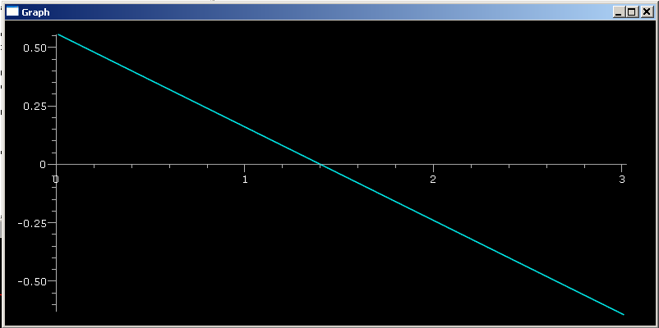
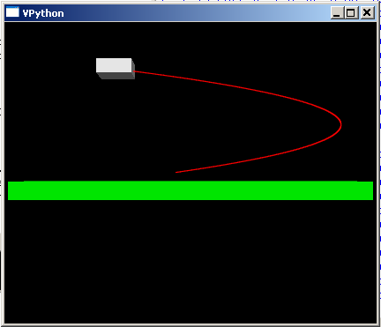
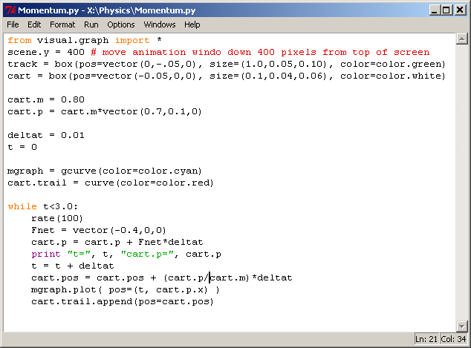
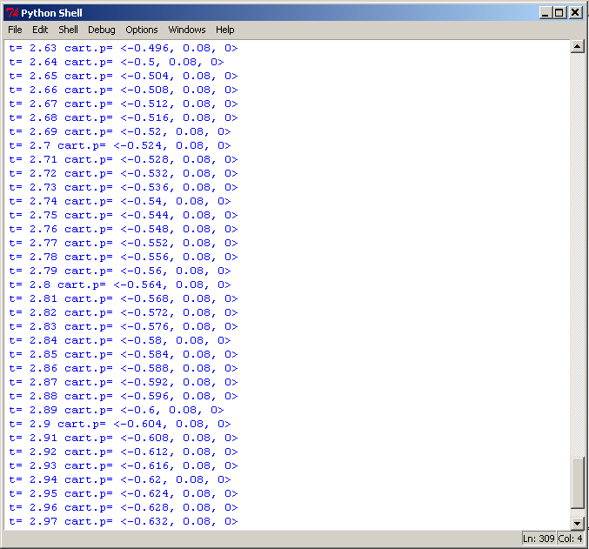

Data Analysis and Conclusion Questions:
- Delta p = p(f) – p(i) = <-0.004,0,0> kg*m/s
- F(net)*delta t = <-0.4,0,0>*0.01
=<-0.004,0,0> kg*m/s
- Since both the change in momentum and the Force times the change in time are <-0.004,0,0> kg*m/s, we can conclude that the change in momentum is equal to the net Force times time.
- The only force applied to the cart is in the x-direction; therefore, the y and z components do not change because there is no force to alter them from a constant trajectory.
Conclusion:
Using VPython, a successful attempt was made at modeling the motion of a cart in three dimensional motion. The program allowed the momentum of the cart to be tracked along its path in order to determine its change as well as observe the properties of the Impulse/Momentum theory. Additionally, the path of the cart was graphed to establish additional relationships with the position and velocity in relation to time through force and effects on momentum.

